Transaction scenarios

Microsoft Dynamics 365 Finance & Operations (M365)

AP Group :
Team leader: Amira Allam
Group members: Mohamed khairy
Sohila Ashraf
Maria Bassem

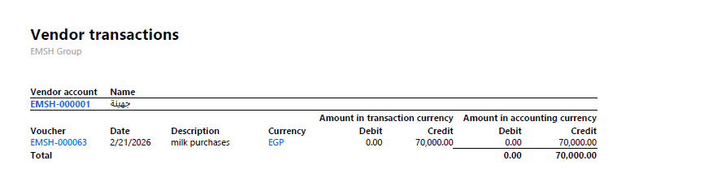

Vendor 1 – EMSH-000001 (جهنية)
Transaction:
Date | Description | Credit
2/1/2026 | Milk purchases | 70,000
Meaning:
The company purchased milk worth 70,000 EGP from this supplier.
Accounting entry:
Debit Purchases / Inventory
Credit Accounts Payable (Vendor)
Total payable to this vendor:
70,000 EGP

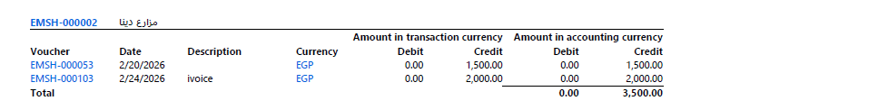

Vendor 2 – EMSH-000002 (مزارع دينا)
Transactions:
Date | Description | Credit
2/20/2026 | Invoice | 1,500
2/24/2026 | Invoice | 2,000
Total:
3,500 EGP
Meaning:
Two invoices were recorded from this supplier.

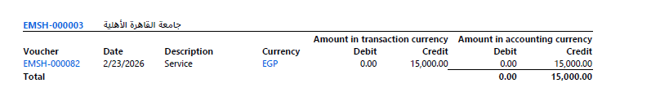

Vendor 3 – EMSH-000003 (جامعة القاهرة الأهلية)
Transaction:
Date | Description | Credit
2/23/2026 | Service | 15,000
Meaning:
The company received a service from this vendor.
Total payable:
15,000 EGP

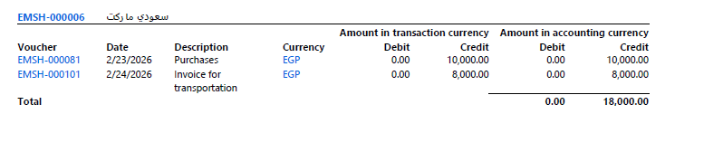

Vendor 4 – EMSH-000006 (سعودي ماركت)

Transactions:

Date Description Credit
2/23/2026 Purchases 10,000
2/24/2026 Invoice for transportation 8,000

Total payable:
18,000 EGP
Meaning:
The company purchased goods and paid transportation costs from the same vendor.

